Q1 and Q2 are both compulsory. Answer both questions.

Q1. Examine the flow chart that follows and read the explanation below before answering the sub-question.

[Explanation of Flow Chart]
This flow chart describes processing that enlarges a grayscale image that has 256 intensity levels.

(1) Prior to enlargement, the image is a rectangular image that consists of “m” pixels in the horizontal direction and “n” pixels in the vertical direction. The intensity value (a value from 0 to 255) of each pixel is stored in an array “A” with “m” columns and “n” rows. After the image is enlarged by a factor of “w,” the intensity value of each pixel is stored in an array B with “m × w” columns and “n × w” rows. Assume that “m” and “n” are integers greater than or equal to “2,” and that “w” is an integer greater than or equal to “1.”

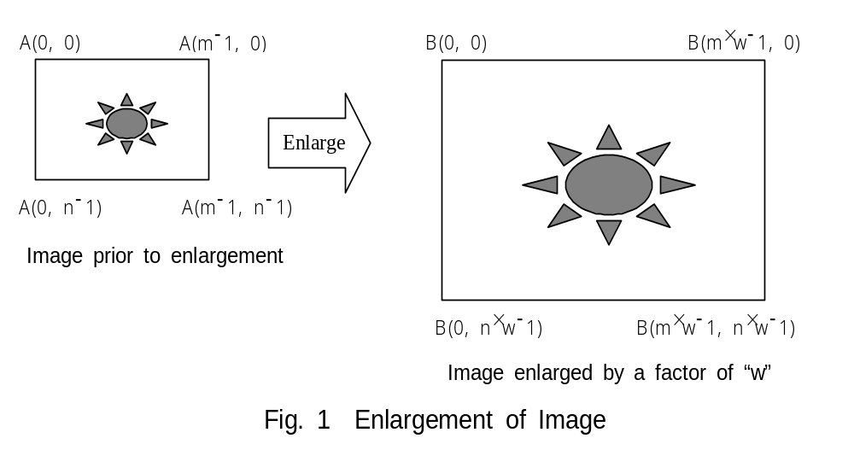

(2) The process described in the flow chart derives the intensity value for each pixel after enlargement (array B) from the corresponding intensity value for each pixel before enlargement (array A). Sometimes, the “x” or “y” values for the pre-enlargement coordinates that are obtained through the inverse transformation from the post-enlargement coordinates are not integers. Therefore, as shown in Fig. 2, below, the intensity value is calculated according to the following formula, and is based on the intensity value of the four pixels (with integer coordinates) in the vicinity of the coordinates (x, y), and the horizontal and vertical distance (p and q) from those pixels.

Intensity value = (1 − q) × {(1 − p) × A(ix, iy) + p × A(ix + 1, iy)}
+ q × {(1 − p) × A(ix, iy + 1) + p × A(ix + 1, iy + 1)}

“p” and “q” are both real numbers that are greater than or equal to 0 and less than 1. “ix” and “iy” are the maximum integers less than or equal to “x” and “y,” respectively.

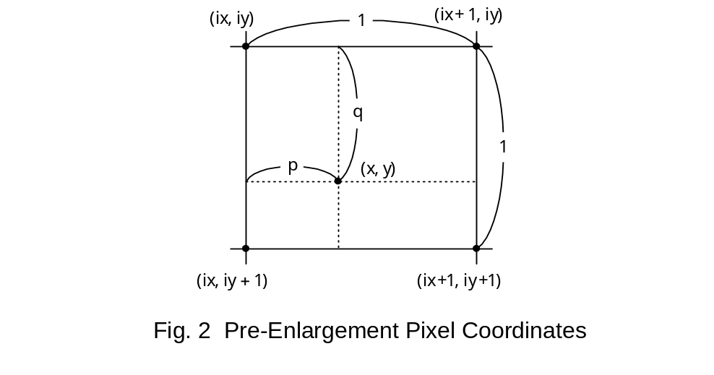

(3) If any of the pixels near the coordinates (x, y) that were derived through reverse conversion do not exist in the pre-enlargement image, the intensity value for the adjacent pixel that does exist in the pre-enlargement image is used. For example, if coordinates (ix, iy) and (ix, iy + 1) correspond to pixels on the right-hand edge of the pre-enlargement image, then A(ix, iy) will be used for A(ix + 1, iy), and A(ix, iy + 1) will be used for A(ix + 1, iy + 1). In addition, when the coordinates (ix, iy) and (ix + 1, iy) correspond to pixels on the bottom edge of the pre-enlargement image, then A(ix, iy) will be used for A(ix, iy + 1), and A(ix + 1, iy) will be used for A(ix + 1, iy + 1).
[Flow Chart]
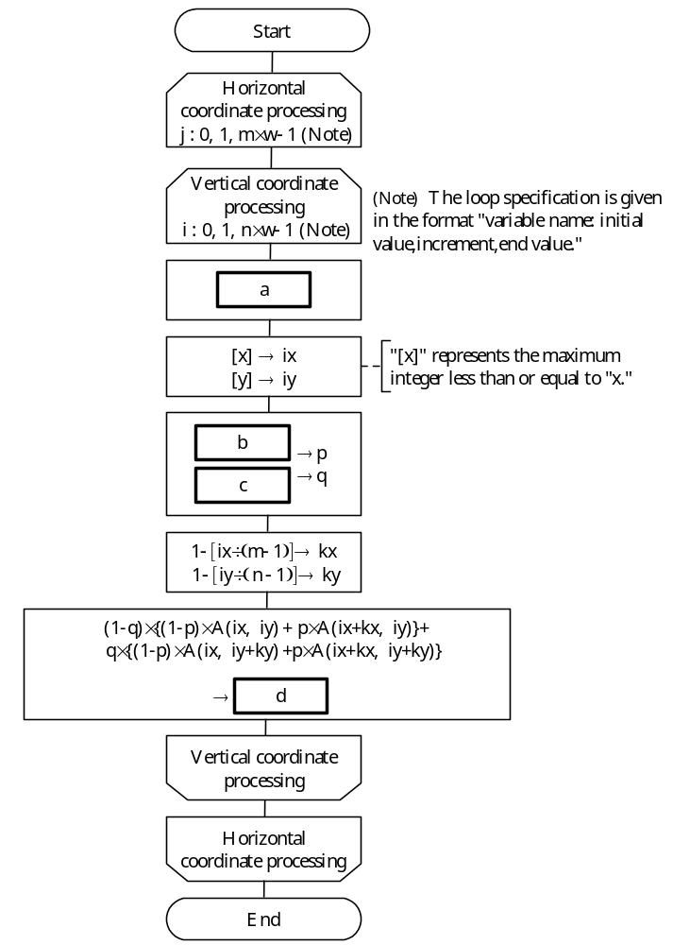

Sub-Question
Select the correct answers to be inserted in to the corresponding boxes () in the flow chart from the choices provided below:

Answer group for a:
a) j × w → x b) j × w ÷ n → x c) j × n ÷ w → x
i × w → y i × w ÷ m → y i × m ÷ w → y
d) j ÷ w → x e) n × w ÷ j → x f) w ÷ j → x
i ÷ w → y m × w ÷ i → y w ÷ i → y

Answer group for b and c:
a) iy − i ÷ w b) j − ix ÷ w c) x − ix
d) y − iy e) (i − iy) ÷ n f) (ix − j) ÷ m
g) (x − ix) ÷ w h) (y − iy) ÷ w

Answer group for d:
a) i, j b) ix, iy c) ix × w, i
d) ix × w, iy × w e) j, i f) j, iy
g) j, iy × w h) j × w, i × w

Ans: Đáp án a – D, b – C, c – D, d - E. Ta có là tọa độ thực trước khi giãn w lần của tọa độ (j,i) của phần được vẽ: x * w = j, y * w = i => đáp án a – D. Ta có p, q là tọa độ của điểm (x,y) như hình vẽ: p = x – ix, q = y – iy. Phần d là tính giá trị của B[j,i]

